Distributed Training- the different variations of SGD

Gradient descent is one of the most popular algorithms to perform optimization and by far the most common way to optimize neural networks. At the same time, every state-of-the-art Deep Learning library contains implementations of various algorithms to optimize gradient descent. While explanations on each method can be found, most of them are for a single node training- it is assumed that training happens on a single GPU/CPU. With the size of neural networks growing each day, a number of distributed and parallel training algorithms have been developed. The aim of this blog post is to explore some of these basic techniques of distributed training. We will be using Stochastic Gradient Descent as a specific case in this post. However, the overall concepts remain the same for most other optimization algorithms.

Parallelism in neural networks can be brought about in two major ways- Data Parallelism and Model Parallelism. Data parallelism is parallelization across multiple nodes in parallel computing environments. It focuses on distributing the data across different nodes, which operate on the data in parallel. The alternate paradigm, in Model Parallelism, the parts of the model are distributed on different nodes. It could be such that 1/4th of the layers sit on Machine A, 1/4th on B and ½ on C. We will focus mostly on Data Parallelism, and even further, on the Stochastic Gradient Descent algorithm.
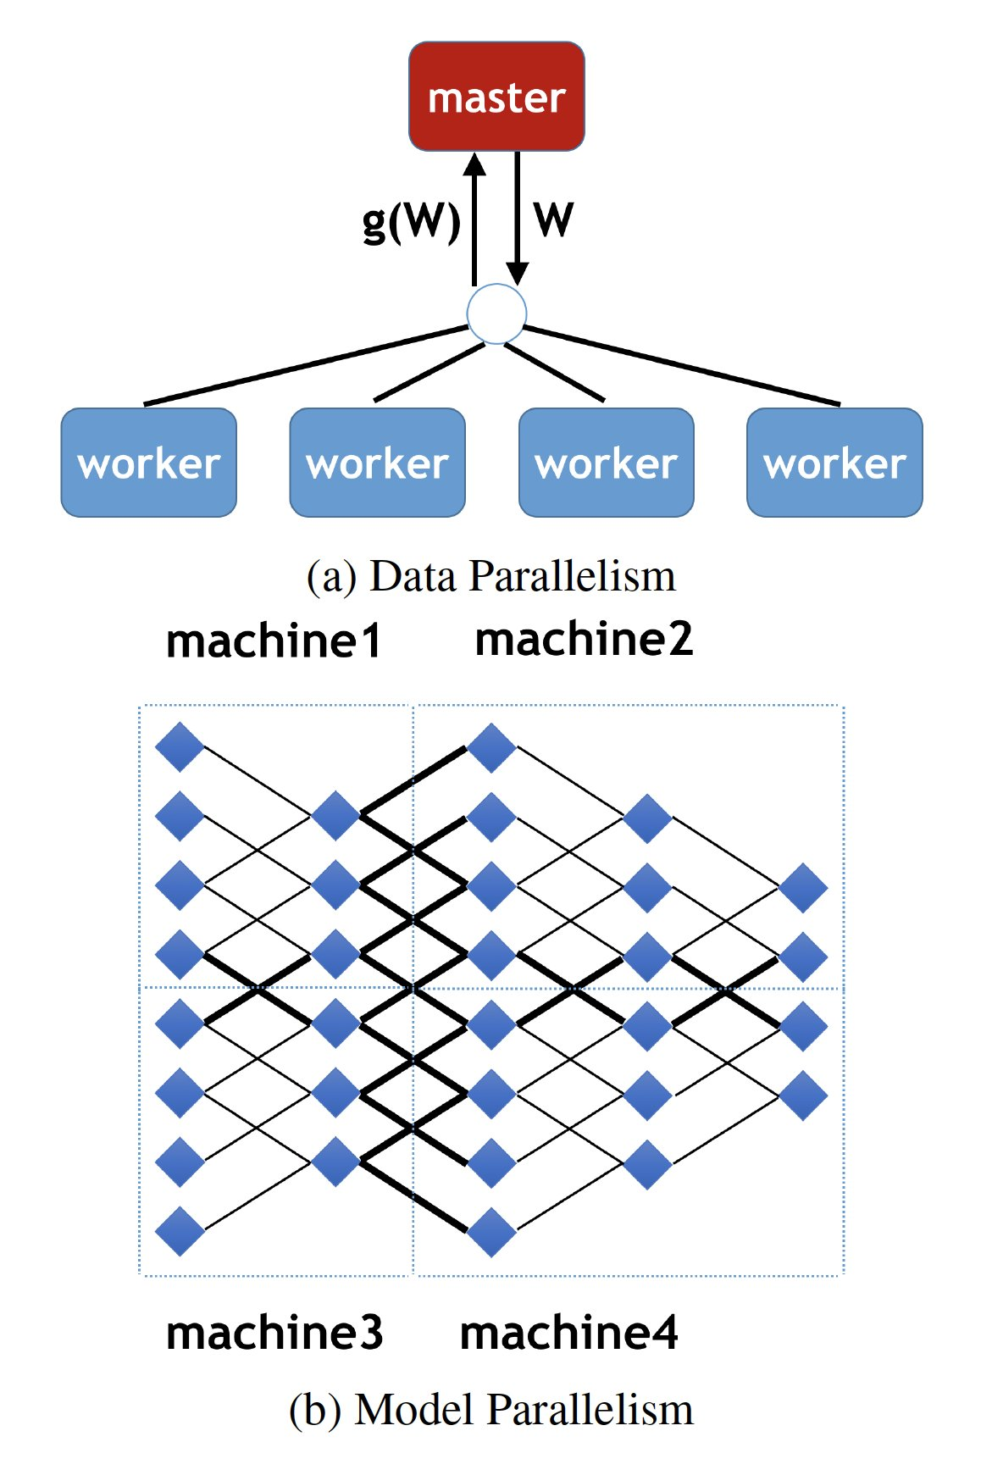

SGD inherently is a sequential algorithm. The weights are initialized to zero at the start of the algorithm. With each step (one pass over a batch of training data), the gradient is updated in a direction that leads towards a minimum in the cost function. In general, running it provides good convergence but can be slow particularly on large datasets. This is where parallel methods come in.

Parallel methods can be of two types- synchronous, meaning all the computing nodes are in sync with each other during the process of execution, or asynchronous, w here each machine works at its own rate. In both cases, our parameter of consideration is the model’s weights- since each node trains on a different part of the data, the weights will be different. Simultaneously, our ultimate aim is to train over the entire dataset- all these different sets of weights have to be combined a number of times to generate the final model. The key difference lies here- as to whether we update the weights on all the does at the same time, and if so, when.

Synchronous training:

Synchronous training is when we update the weights on all the nodes at regular intervals of time. Depending on when the update is triggered, it can be classified into three major categories: Full sync, K-sync and K-batch sync.

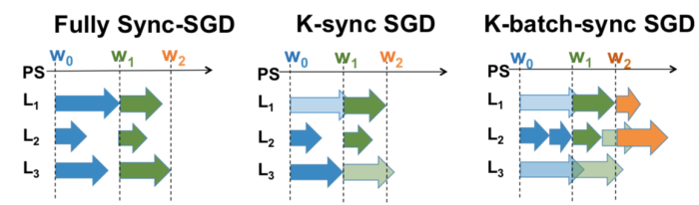
- In a fully sync-SGD, we wait for all the learners to complete computation. Once one step is complete, the model weights are then combined and distributed to all learners, and the next batch of training begins. We can see how ineffecient this is- the learners are idle for most of the time!
- To resolve the above, instead of waiting for all learners to complete, we can wait for “k” of them. This gives rise to K-sync gradient descent. This method definitely looks better than the previous one, but it still does have a few caveats- some learners still have to wait until K of them have completed execution, and we are throwing away the work we did at N-k learners.
- To find a balance between the two, one of the most popular synchronous SGD methods involves updation at the end of K-batches of data, instead of K workers.

Remember that each of the above methods take a toll on how accurate my model will be- fully synchronous performs the best, K-batch achieves an accuracy close to that of fully sync, and k-sync the least.

Asynchronous SGD:

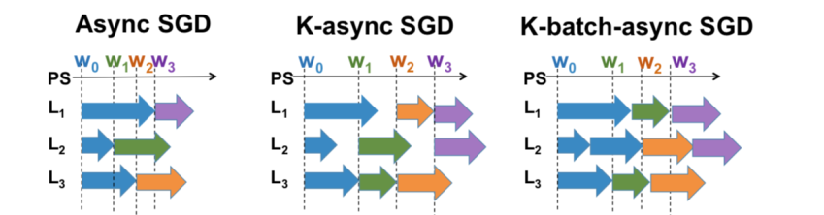
Parallels can be drawn from the above- we replace the synchronous nature with asynchronous calls. This way, we are able to use the available resources highly efficiently.

However, this brings about a whole new set of problems we were not initially concerned about- Staleness.
Let us look closely at what happens when the first worker finishes execution. Given that the weights have been updated, we should send these weights to all other workers. But now, the other workers haven’t completed their execution yet, and are not ready to accept weights. This inturn means that the computation I am running for the rest of the time on the other workers “may” or “may not” be relevant to my current computation- it may as well be moving away from my target function. This is called “Staleness”. The above phenomena can increase my time to convergence.

The above is compensated for, and not quite tackled, by a variety of methods. One way is to modify the learning rate depending on the staleness- attribute a smaller learning rate to stale components. This way, we can ensure that even if my stale worker is headed in the wrong direction, the magnitude is relatively small.

One thing to note, is that we have been ignorant of the way the parameters are actually communicated with each other- we have assumed it just “happens”. Efficient communication plays a major role in training time, and there are several ways in which this can be implemented. The two major approaches include having a centralized server collect all the parameters and distribute them, against using a decentralized version where the nodes communicate with a specific set of other nodes to share. This where yet another component- the network bandwidth between these nodes also comes into play.

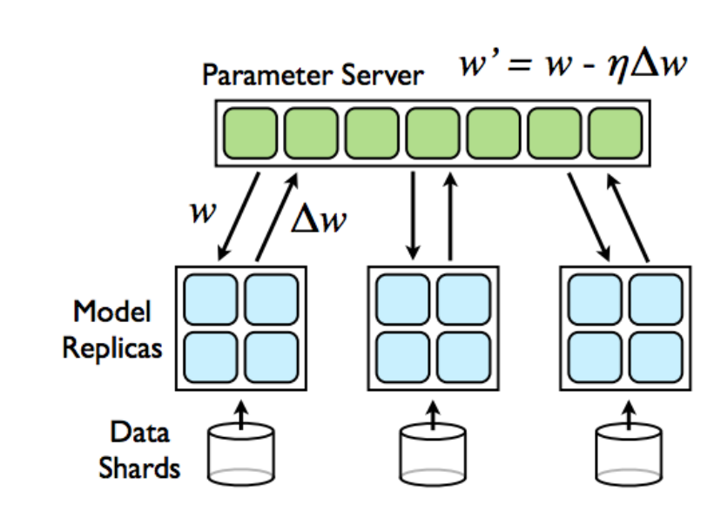
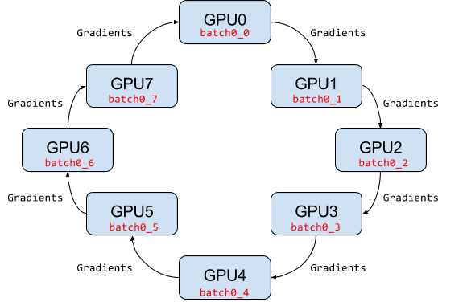
Each sentence in the above paragraph can be separate articles themselves, and is an active area of research. With the usage of neural nets increasing exponentially, training fast, accurate models becomes imperative. Giants such as Google, Facebook and IBM pursue this area of research actively, and are coming up with solutions every day. Popular deep learning frameworks have also started to support distributed training- such as Tensorflow, Caffe and PyTorch.

Conclusion:

In the above article, we have explored a very high overview of how a sequential algorithm (SGD) is converted into a parallel algorithm. We have looked at some of the basic methods of how distributed training works. I have attached a set of papers which dive deep into each of the above topics (in chronological order), and is an interesting read for those who would like to track the evolution of distributed training.

I would like to thank Prof. Parijat Dube, who has been instrumental in my understanding of this vast subject. Additionally, I attribute some of the images to his presentations.

Papers to Read:

1) Large Scale Distributed Deep Networks, Dean et al
2) Parallelized Stochastic Gradient Descent, Zinkevic et al
3) The tail at scale- Jeffrey Dean and Andr Barrosso
3) On variance reduction in stochastic gradient descent and its asynchronous variants- Reddi et al
4) REVISITING DISTRIBUTED SYNCHRONOUS SGD- Chen et al
5) Hogwild!: A Lock-Free Approach to Parallelizing StochasticGradient Descent- Retch, Nui et all
6) Asynchronous Decentralized Parallel Stochastic Gradient Descent- Chen et al
7) 1Accelerated Distributed Nesterov Gradient Descent- Lian et al

References:
https://arxiv.org/pdf/1604.00981.pdf

